August 1, 2024

Dear Parents and Guardians,
We are excited to welcome your child back to school for another fantastic year of learning and growth! To ensure a smooth start to their 1st Grade school year, we kindly request your attention to the following back-to-school supply list. We understand that choosing school supplies can be overwhelming, for optimal classroom use and compatibility, we recommend the following brands for certain items to ensure that all students have the necessary tools for success.

Thank you for your support in preparing your child for a wonderful school year!

Sincerely,
First Grade Team

1st Grade School Supply List
2024-2025

Pencil Box | 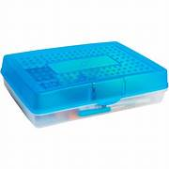 | 1
Ticonderoga Pencils | 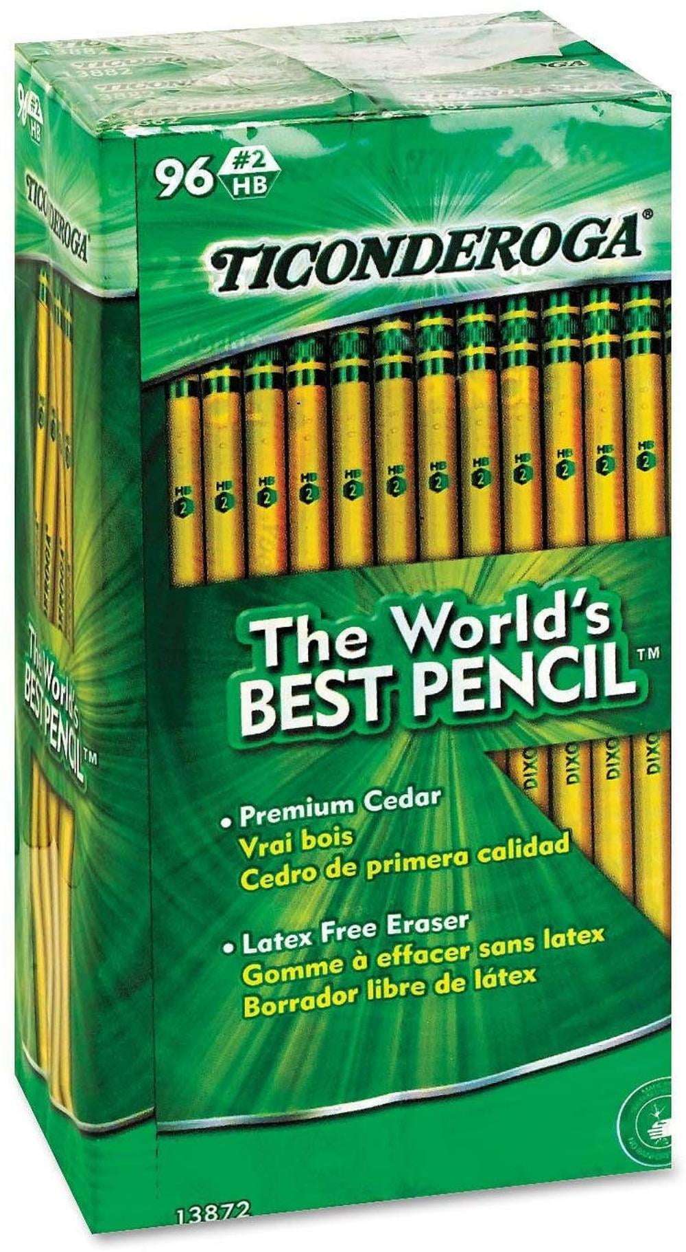 | 2
Crayola Crayons | 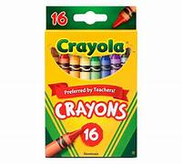 | 4
Elmer’s Glue Sticks | 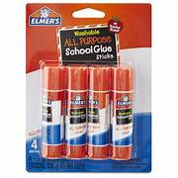 | 2
Scissors  (blunt tip) | 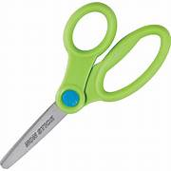 | 1
Composition Book  (black and white only) | 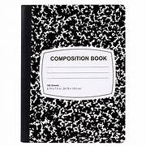 | 2
Tissue Boxes | 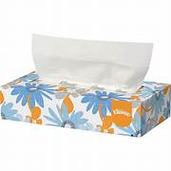 | 3
Clorox Wipes | 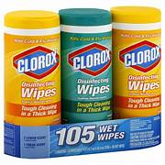 | 2
Expo Markers  (only black) | 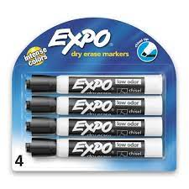 | 2
Expo Eraser | 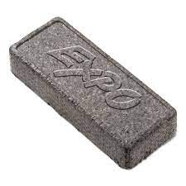 | 1
Sandwich Ziploc Bags | 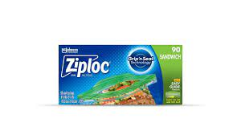 | 1
Gallon Ziploc Bags | 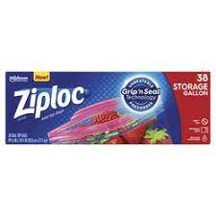 | 1
Crayola Markers | 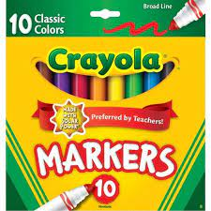 | 2
Paper Mate Erasers | 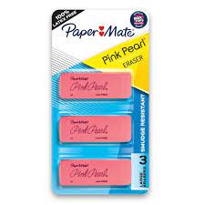 | 1

